Sensors used for outflow measurement:

1. Prosonic Flow 93T (Ultrasonic sensor) by Endress+Hauser

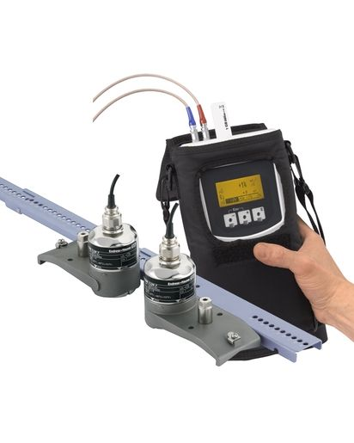

1. FLOW METER-
2. Uf 831 CO dual-chord converter

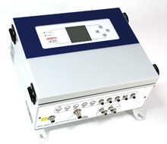

1. SM 1684 wetted probes

